Q8. Read the following description of an assembler program and the program itself, and then answer sub-questions 1 and 2.

[Program Description]
“n” consecutive words are regarded as a bit string consisting of 16 × n bits. The sub-program SHIFT shifts this bit string right by m positions.

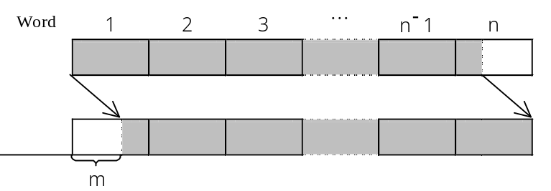
Fig. 1 Processes by the Subprogram SHIFT

(1) The main program stores the following values in GR1 through GR3, respectively, and then passes these values to SHIFT.
GR1 : Address of the first word of the bit string
GR2 : m
GR3 : n
(2) Assume that 1 ≦ n ≦ 32767 and that 0 ≦ m ≦16.
(3) The shifted bit string is stored in the original area.
(4) “0” is stored in the empty bit positions before the left end of the string. The bits removed from the right side of the register are discarded.
(5) The functions of the RPUSH and RPOP macro instructions used in the program are as described below:
RPUSH : Saves the contents of GR1 through GR7 into the stack.
RPOP : Restores the contents of the stack into GR1 through GR7.
[Program]

(Line No.)
1 SHIFT START ;
2 RPUSH ; Save registers
3  ;
4 SUBA GR4,GR2 ; (16−m)→GR4
5 LAD GR5,0 ; ‘0’ bit string to be stored at the left end
6 LOOP SLL GR5,0,GR4 ; Move to the left end the remaining bit string from the previous word
7 LD GR0,0,GR1 ; The bit string in the current word→GR0
8  ;
9 OR GR0,GR5 ; Catenate the left-over bit string
10 LD GR5,0,GR1 ; Save bit string in current word into GR5
11 ST GR0,0,GR1 ; Store catenated bit strings into the current word
12 LAD GR1,1,GR1 ; Obtain the address of the next word
13 SUBA GR3,=1 ;
14  ;
15 RPOP ; Restore registers
16 RET ;
17 END ;

Sub-question 1
From the answer groups below, select the correct answer to insert in the boxes  in the program.

Answer group for “a”:
a) AND GR4,=16 b) LAD GR4,16
c) LD GR4,16 d) OR GR4,=16

Answer group for “b”:
a) SLL GR0,0,GR2 b) SLL GR0,0,GR4
c) SRL GR0,0,GR2 d) SRL GR0,0,GR4

Answer group for “c”:
a) JMI LOOP b) JOV LOOP
c) JPL LOOP d) JZE LOOP
Sub-question 2
The LAD instruction in line 5 has been replaced with the following three instructions in order to store the bit substring removed from the right end in the open bit positions at the left end of the string, as shown in Fig. 2. From the answer group below, select the correct answer to insert in the box below.

LD GR5,GR1
ADDL GR5,GR3


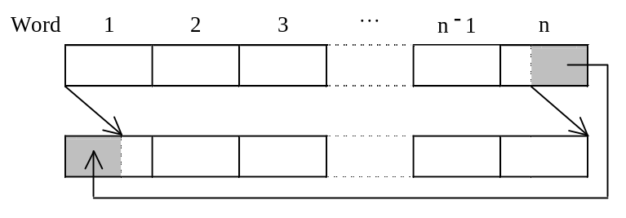
Fig. 2 The removed bit substring is stored on the left side.

Answer group:
a) LD GR5,−1,GR5 b) LD GR5,0,GR5 c) LD GR5,1,GR5
d) ST GR5,−1,GR1 e) ST GR5,0,GR1 f) ST GR5,1,GR1

